Project file

ANNUAL CALL FOR PROPOSALS
2025

APPLICATION FOR

RESEARCH GRANT
& ASSOCIATED FELLOWSHIP

Remember:
Doctoral fellowship = 38 000 €
Postdoctoral fellowship = 60 000 €

  - PhD students: you cannot ask for this subvention.

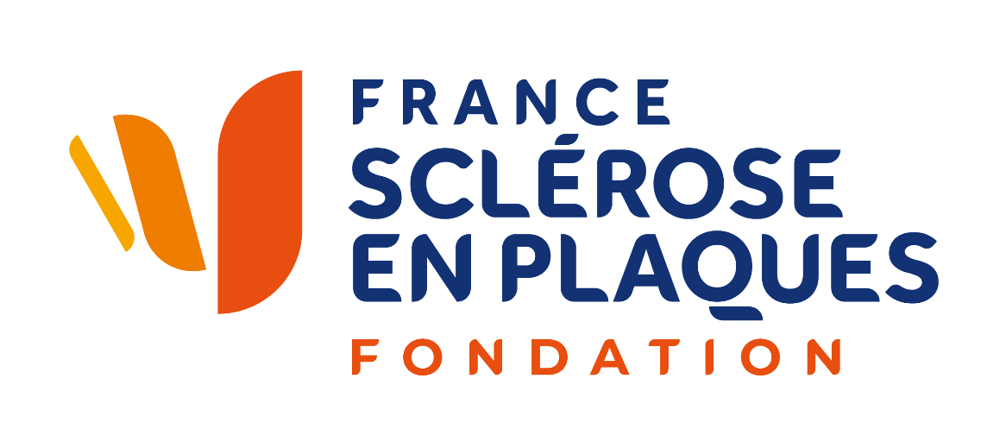
TITLE OF THE PROJECT IN ENGLISH:

200 characters max

PRINCIPAL INVESTIGATOR/COORDINATOR OF THE PROJECT:

Name

Surname
Address

Email

Phone number

Did you receive, as Principal Investigator, a financial support from ARSEP/France Sclérose en plaques Foundation before?
If yes, please, indicate - years of funding, the amount obtained, the length and the title of the project.

CANDIDATE FOR THE FELLOWHIP – only postdoctoral fellow:

Name

Surname

Date of birth
Address

Email

Phone number

Did you receive a fellowship from ARSEP/France sclérose en plaques Foundation before?
If yes, please, indicate - years of funding - the salary obtained - the title of the project.

HOST RESEARCH LABORATORY
Name and Address:

Administrative institution: □ INSERM □ CNRS □ UNIVERSITY □ HOSPITAL □ OTHER:

Last name, first name of the research laboratory/unit director:

Last name, first name of the team leader who will supervise the project:

INFORMATION ABOUT THE PROJECT:

Requested budget (grant + fellowship): euro

IS IT A COLLABORATIVE PROJECT?
Yes No

If yes, name, surname, email, and address of the other investigators:

BIOGRAPHICAL SKETCH OF THE PRINCIPAL INVESTIGATOR OF THE PROJECT

Education, training
Institution and location | Degree | Year | Field of study

Positions and Honors. List in chronological order, concluding with your present position. List any honors. Include present membership on any Federal Government public advisory committee.

Selected publications (in chronological order). List of publications related to multiple sclerosis research in the last 3 years, listing original papers and reviews, separately; Indicate with an * the works funded by ARSEP/France Sclérose en plaques and attach reprints and papers in press.

Research Support. List selected ongoing or completed (during the last three years) research projects (federal and non-federal support). Begin with the projects that are most relevant to the research proposed in this application. Briefly indicate the overall goals of the projects and your role (e.g. PI, Co-Investigator, Consultant) in the research project.

CANDIDATE FOR THE FELLOWHIP:

For which fellowship year do you apply?
Tick the corresponding square for the year for which you are requesting support from France Sclérose en plaques Foundation.
NB: the 1st year of a postdoctoral fellowship is the one just after the PhD defence.

 | First | Second | Third | Fourth | Fifth | Sixth
PhD
Postdoctoral position

Do you apply for an institutional position?
Yes No
If yes, which one?
- Date of decision:

Do you apply for a fellowship from another institution?
❒ Yes  No
If yes, which one?
- Date of decision:

Please, send the answer to scientific@francesep.org when you receive the information (positive or negative).

Date wished for the beginning of the training course?
Remember: The fellowship granted by France Sclérose en plaques Foundation will have to start before February 1st, 2026

What is your cursus and professional experience (degrees, awards, …)?
Please, join your CV (as complete as possible) and letter(s) of recommendation of your previous research supervisor(s).

Applicants publications
Underline the applicant's name

PARTICIPANTS TO THE PROGRAMME

Please list in order, scientists/clinicians, engineers, technicians.

Name, first name, date of birth | Title and degrees | Institution | Percent of research time on the project
Principal Investigator

SUMMARY OF THE RESEARCH PROJECT (2000 characters)
Specify:
- Project rationale;
- The scientific aims;
- The methodology;
- Applications to human pathology and therapy.

DESCRIPTION OF THE RESEARCH PROJECT

(no more than 10 pages, Arial 10, single spacing, figures included and references not included)
For clinical trials, add the entire protocol.

Please follow this outline:
- Objectives,
- Rationale and scientific background,
- Preliminary results if existing (with figures showing the data), mandatory if renewal
- Research project including methodology and expected results.
- Expected results and alternative strategies
- Work plan (for example a gantt chart)

Specify what will be the therapeutic or clinical application or the direct benefit of your project for people with MS or a related disease. When do you foresee this application / benefit?

FUNDING OF THE RESEARCH TEAM(S) FOR THE Grant + Fellowship’S YEAR

- Indicate the other sources of funding (note amount with all taxes included)

Team | Funding sources | Laboratory expenses | Equipment | Total

- Specify other grant applications and potential overlaps with the presented project (objectives & budget).

FUNDING REQUESTED FOR THE SUBMITTED PROJECT

1. Funding requested:

Laboratory expenses | Equipment | Salary | Total

- Attach justification for the budget

- Total budget of the project and other funding sources for the project, including those submitted.

Candidates who have been supported by France Sclérose en plaques Foundation
must send a research report at the end of the year.

Signature of the principal investigator of each team implicated in the project and of the fellowship candidate

Name(s) signature(s) and date:

