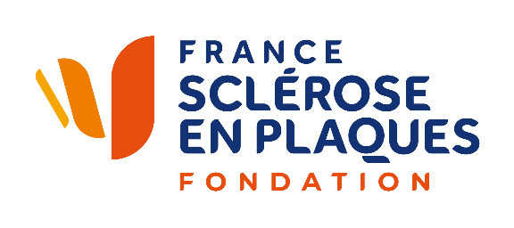
MS Meeting
PARIS

Abstract Submission

France Sclérose en plaques encourages the submission of abstracts on any research or clinical topic related to MS and associated disorders.
Abstracts are not restricted to the topics developed at the MS Meeting.
Abstract submission is strongly recommended for those who have been granted or those who expect to be granted.

Abstract Preparation
- Abstracts must be submitted online via the abstract submission site. Abstracts submitted by email or fax will not be accepted.
- The full abstract text, including title, name of the authors, and affiliation may not exceed 3 000 characters, spaces included.
- Abstracts must be submitted in English.
- All abbreviations must be defined the first time they appear in the text.
- Use generic drug names.
- Tables, charts, or other graphics may not be included.

APPLICATION PROCEDURES
- Candidates must send their abstract to scientific@frsep.org.

MORE INFORMATION: scientific@francesep.org

