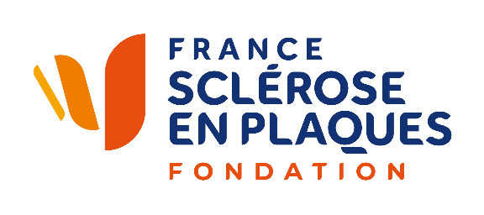
MS Meeting
PARIS

TRAVEL GRANTS FOR YOUNG RESEARCHERS

France Sclérose en plaques Foundation offers meeting "travel grants" to help young researchers to defray the costs of their travel expenses to reach the meetings organized by France Sclérose en plaques in Paris (MRI Workshop and MS Conference) and their accommodation for one or two night(s).

Eligibility
- Candidates must follow a PhD scientific program or a post-doctoral course or a MD medical program.
- They must be under 40 years old.
- Applicants must submit a poster as first author and presented it on the day of the meeting, if selected by the scientific committee of the meeting.
- Travel to Paris should be done in the economic class.
- The hotel category should not exceed 3.

APPLICATION PROCEDURES
- Candidates must send their CV and their abstract to scientific@frsep.org.

NOTE
- The abstract can be selected for a short oral communication. if you do not want, please mention in the mail.
- Selected researchers will be refunded on presentation of travel tickets and invoices.
- The reimbursement may not exceed 600 €.
- The number of travel grants will be dependent on the resources available to the Foundation.

MORE INFORMATION: scientific@frsep.org

